Image Recognition with IBM Cloud Visual Recognition

Phase 4: **Development Part 2**

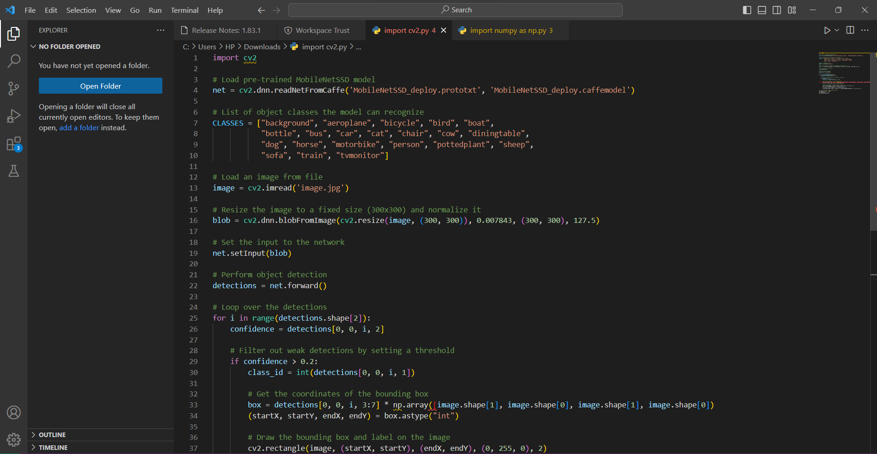

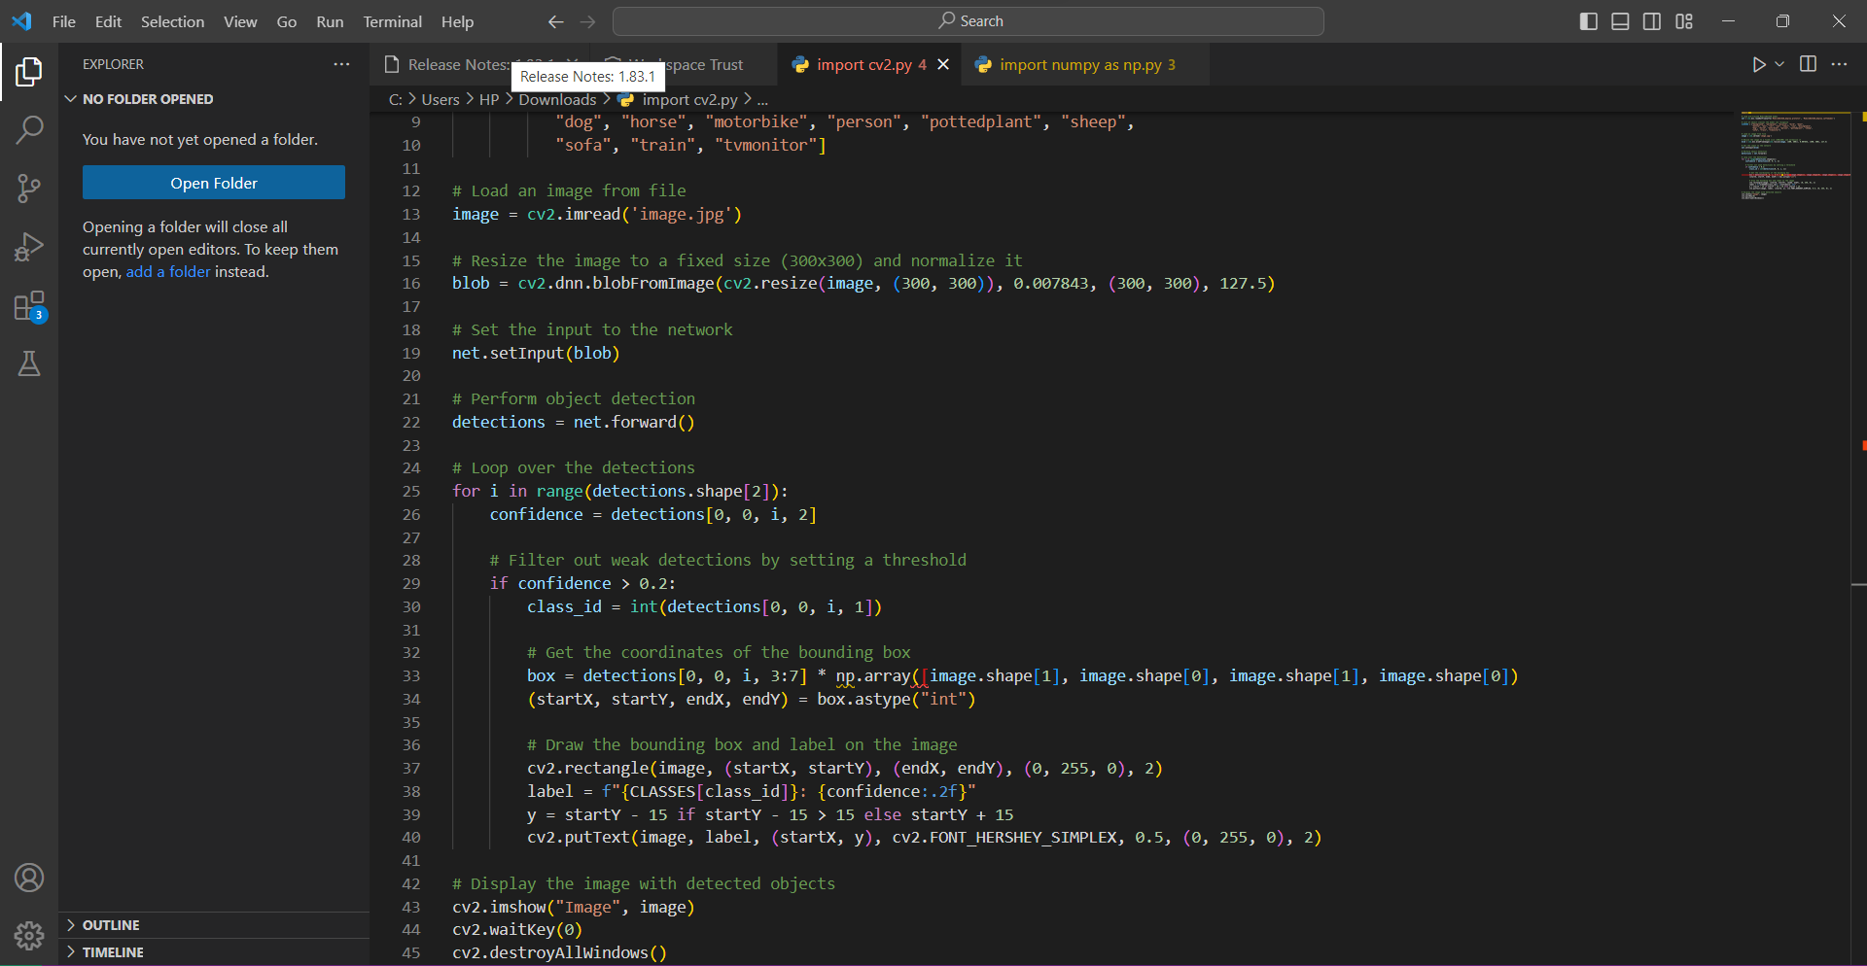

In this code:

1. We load the pre-trained MobileNetV2 model, which has been trained on the ImageNet dataset, containing a large number of object classes.
2. Load an image that you want to recognize. Ensure 'image.jpg' exists in the same directory or specify the correct file path.
3. Preprocess the image to match the input requirements of the MobileNetV2 model.
4. Use the model to make predictions on the image.
5. Decode the predictions to get the top three recognized labels with their corresponding scores.
6. Display the recognition results, including the top label with the highest score.

Running this code will recognize objects in the provided image and display the top recognized labels and their corresponding scores.

Output:

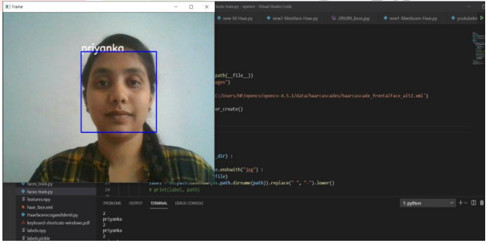

EXPERIMENT AND RESULT:

Step I – Finding and Detecting Human face and Non-human face

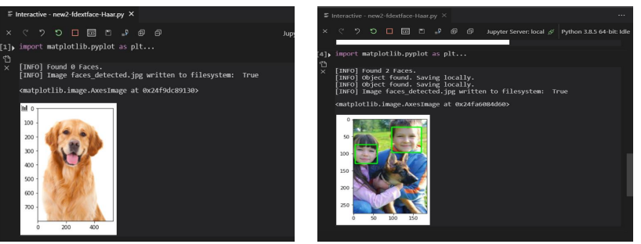

Step II – Detecting Multiple Facs from Group Photograph

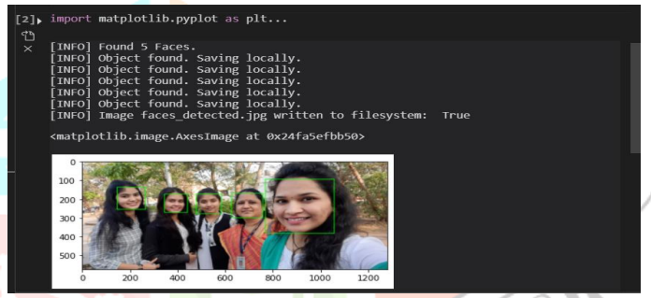

Step III - Detecting Features of face using Dlib, Python and OpenCV

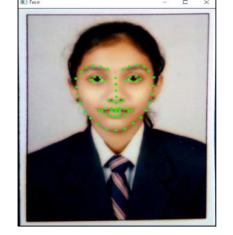

Step IV - Face Recognition

